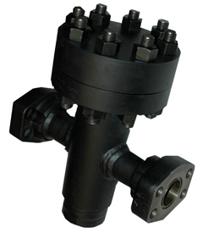

High Pressure Simplex Strainers

For higher pressure duties we are able to offer a simplex strainer range that can extend the working pressure of the basket strainer up to a maximum of 414 Barg (6000 psi) for a ANSI 2500 rating.
Manufactured in carbon steel or stainless steel and fitted with stainless steel baskets in any perf or mesh size (see simplex web page for dimensions), they can be fitted with any flange standard but most frequently ANSI 900, 1500, 2500 and SAE.

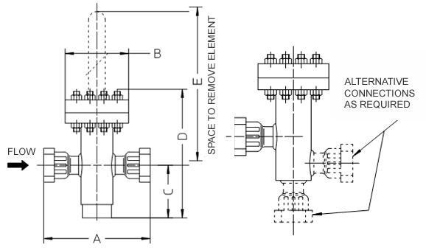

BORE SIZE | COMMON DIMENSIONS (mm) |  |  |  |  | MASS (dry)
 | A | B | C | D | E | Kg
DN20 | 300 | 216 | 200 | 350 | 445 | -
DN25 |  |  |  |  |  | -
DN32/40 |  |  | 230 | 400 | 475 | -
DN50 | 350 |  | 240 | 415 | 485 | -
DN65 |  |  | 240 | 415 |  | -
DN80 | 470 | 268 | 260 | 435 |  | -

